Q)Write a program in c that process a string to the shared memeory by program 1 and program2 read the contentand print the same content to verify it.

Code:

Program1:

#include<stdlib.h>
#include<unistd.h>
#include<stdio.h>
#include<string.h>
#include<sys/ipc.h>
#include<sys/shm.h>
#include<sys/types.h>
#include<memory.h>

int main()
{
int shmid=shmget((key_t)5255,10,0666|IPC_CREAT);
void *memory=NULL;
memory=shmat(shmid,NULL,0);
char str[]="hello";
char *p;
p=(char*)memory;
memset(p,'\0',10);
memcpy(p,str,strlen(str));

return 0;
}

Program2:

#include<stdlib.h>
#include<unistd.h>
#include<stdio.h>
#include<string.h>
#include<sys/ipc.h>
#include<sys/shm.h>
#include<sys/types.h>
#include<memory.h>

int main()
{
int shmid=shmget((key_t)5255,10,0666|IPC_CREAT);
void *memory=NULL;
memory=shmat(shmid,NULL,0);
//char str[]="hello";
char *p;
p=(char*)memory;
//memset(p,'\0',10);
//memcpy(p,str,strlen(str));
printf("%s",p);

return 0;
}

Output:
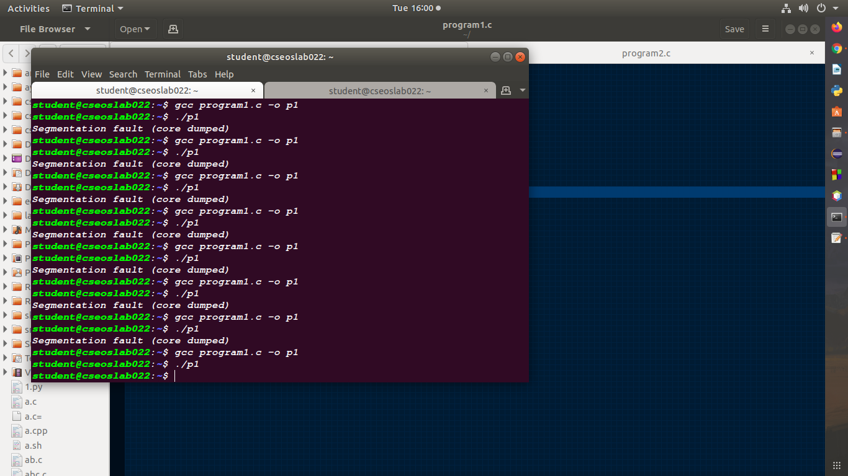
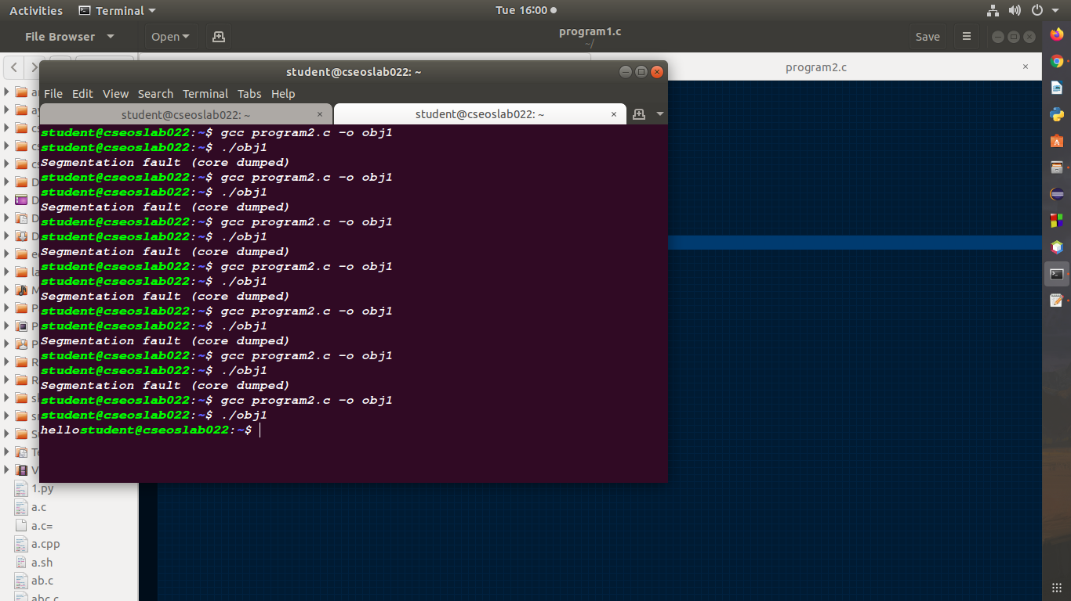

Q) Write a program in C in which an array of elements are supplier by user written into the shared memory by program1 and program2 sorts the content of the array after which the program1 prints the sorted array.

Code:

Program3:
#include<stdlib.h>
#include<unistd.h>
#include<stdio.h>
#include<string.h>
#include<sys/ipc.h>
#include<sys/shm.h>
#include<sys/types.h>
#include<memory.h>

int main()
{
int arr[20],n,i;
scanf("%d", &n);
arr[0]=n;
for(i=1; i<=n; i++)
scanf("%d",&arr[i]);

int shmid=shmget((key_t)5255,10,0666|IPC_CREAT);
void *memory=NULL;
memory=shmat(shmid,NULL,0);
int *p=NULL;
p=(int*)memory;
memset(p,'\0',10);
memcpy(p,arr,sizeof(int)*(n+1));
sleep(10);
int *arr2;
arr2=(int*)memory;
n=arr2[0];
for(i=1; i<=n; i++)
printf("%d",arr2[i]);

return 0;
}

Program4:

#include<stdlib.h>
#include<unistd.h>
#include<stdio.h>
#include<string.h>
#include<sys/ipc.h>
#include<sys/shm.h>
#include<sys/types.h>
#include<memory.h>

void srt(int arr[], int n)
{
int i,j,t;
for(i=n; i>1; i--)
{
for(j=1; j<i; j++)
{
if(arr[j]>arr[i])
{
t=arr[j];
arr[j]=arr[i];
arr[i]=t;
}
}
}
}
int main()
{
int n,i;
int shmid=shmget((key_t)5255,10,0666|IPC_CREAT);
void *memory=NULL;
memory=shmat(shmid,NULL,0);
int *arr;
arr=(int*)memory;
n=arr[0];
srt(arr,n);

return 0;
}

Output:

